Task1. Select Sample store dataset and create group by

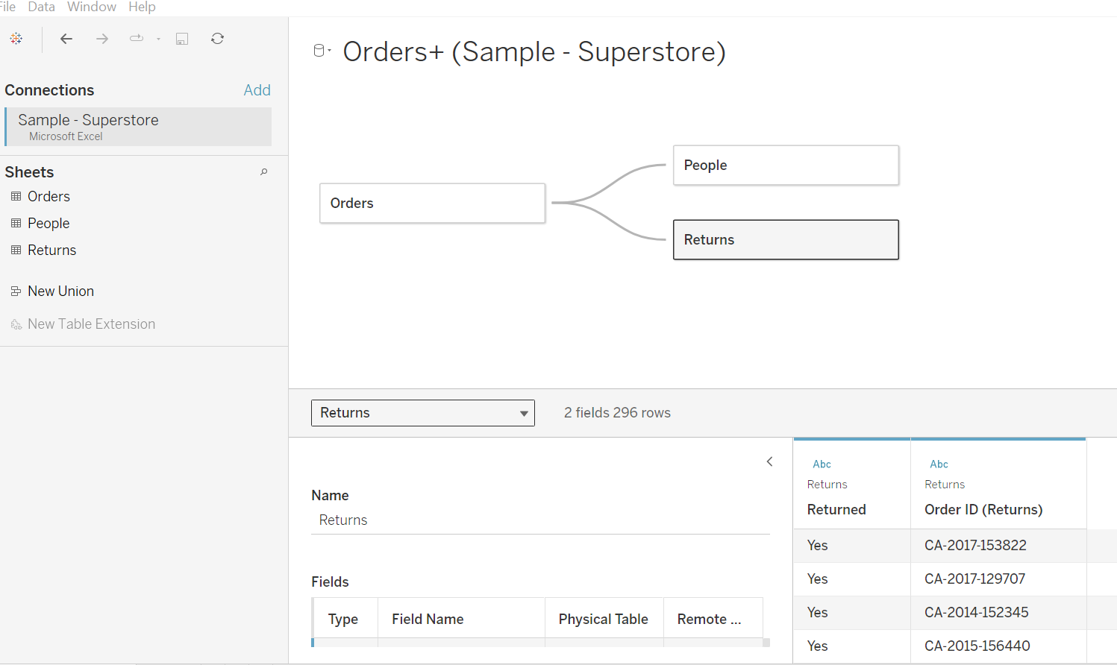

Task 2. Create hierarchy Location

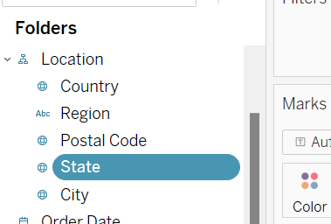

Task 3. Create two Region Primary Region and Secondary Region

Task 3B. Create Calculated Field

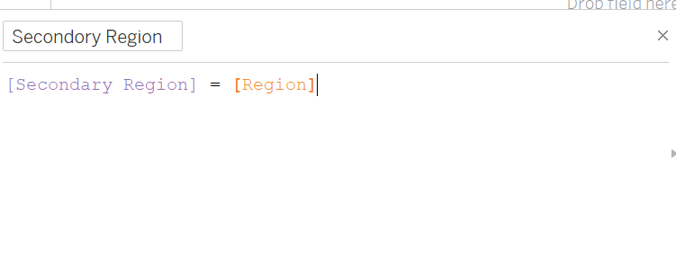

Task 4. Create First Order Date

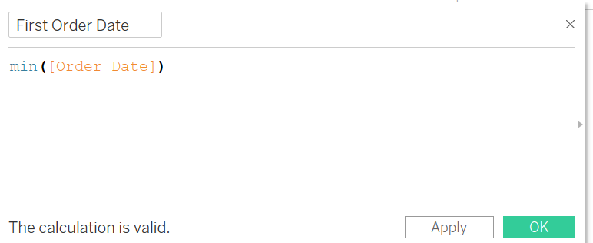

Task 5. Create Dashboard

